

**YEAR: 10**

**SUBJECT: Science**

**Evolution**

**ATAR Pathway**

**Please do not mark this paper.**

**Year 10 Evolution**

**Part A: Multiple Choice (10 marks)**

**Record answers in the answer booklet provided.**

1. **The dog breeds we have today were developed through**
2. Natural Selection
3. Sexual Selection
4. Artificial Selection
5. Acquired Selection
6. **Characteristics of an organism that have the same basic structure are**
7. Mutation
8. Adaptations
9. Homologous
10. Variations
11. **Two bodily structures, found in different species, have different internal bone structures but serve a similar purpose in each organism. This is the best description of**

a) homologous structures

b) vestigial structures

c) analogous structures

d) natural selection

1. **Choose the correct term for the following definition. “Genetic change in the characteristics of a species over many generations, resulting in the formation of new species.”**
2. Natural Selection
3. Evolution
4. Adaptation
5. Mutation
6. **Which of the following is usually an outcome (result) of natural selection?**
7. A species slowly becomes better adapted to its environment.
8. Variations will appear in the offspring (babies).
9. Mutations slowly disappear over time, because they are harmful.
10. A species slowly becomes less adapted to its environment.
11. **According to Darwin’s theory of natural selection, individuals who survive are the ones best adapted for their environment. Their survival is due to the?**
    1. Possession of inherited adaptations that maximise fitness.
    2. Competing with other species
    3. Mutation
    4. Being the strongest and fastest
12. **A population of bacteria is treated with hand sanitizer. Because of genetic variation in the population, what is a possible outcome?**
    1. The population will grow quickly.
    2. All of the bacteria are already resistant.
    3. They will get better at obtaining a food source.
    4. Some may be resistant and survive.

**8. The number and range of different species that exist on Earth is referred to as:**

* 1. heterozygous
  2. genotype
  3. biodiversity
  4. mutation

**9. Which of the following is not required for speciation to occur?**

1. Environmental resistance.
2. Variation.
3. Genetic isolation.
4. Selection pressure.

**10. Charles Darwin was famous for**

1. defining the term evolution.
2. suggesting natural selection was the mechanism of evolution.
3. discovered a fossil that proved evolution
4. inventing the term artificial selection and proposing that it caused evolution.



**Biology 1 & 2 Test   
ATAR Pathway**

**ANSWER BOOKLET**

**NAME:**

**FORM: DATE:**

**ASSESSMENT KEY**

|  |  |
| --- | --- |
| **I CAN STATEMENTS** | **QUESTIONS** |
| **MUST**  Explains the influences of competition and variationon natural selection. | 3, 4, 6, 8, 9, 10, 11, 12, 14, 15, 16, 17 |
| **SHOULD**  Explains evolution in a population, describing the influences of variation which support survival and lead to natural selection. | 1, 2, 5, 7, 11, 13, 14, 15, 17 |
| **COULD**  Uses the position of elements in the periodic table to determine their atomic structure and electron configuration, and makes predictions about bonding types and reactivity of elements. | 15,17, 14 |

**Multiple Choice Short Answer Extended Answer Total**

**/9**

**/38**

**/19**

**/10**

**SECTION ONE: Multiple choice answers**

**Cross (X) through the correct answer.**

|  |  |  |  |  |
| --- | --- | --- | --- | --- |
| **1** | **a** | **b** | **c** | **d** |
| **2** | **a** | **b** | **c** | **d** |
| **3** | **a** | **b** | **c** | **d** |
| **4** | **a** | **b** | **c** | **d** |
| **5** | **a** | **b** | **c** | **d** |
| **6** | **a** | **b** | **c** | **d** |
| **7** | **a** | **b** | **c** | **d** |
| **8** | **a** | **b** | **c** | **d** |
| **9** | **a** | **b** | **c** | **d** |
| **10** | **a** | **b** | **c** | **d** |

**Part B: Short Answer (19 marks)**

11. Darwin’s theory of Natural Selection occurs in four steps. List and describe each step (4 marks)

1. Match the vocabulary word with the proper definition. (3 marks)

**Terms**

Artificial selection Evolution Wallace Natural selection Darwin Fitness

**Definitions**

_____________ Change in species over time.

_____________ One of the first scientists to propose that species change over time.

_____________ Developed a theory of evolution at the same time as Darwin.

_____________ An organism’s relative ability to survive and produce fertile offspring.

_____________ The process by which evolution occurs.

_____________ Selecting for plants and animals with useful traits.

1. Galapagos finches (birds) live on several different islands. Birds from different islands appear different and are known as separate species. It has been proven that all the birds from all the islands originated from the same species.

**Describe** the process of speciation. (What steps are involved?) (3 marks)

1. ____________________________________________________________________________________________________________________________________________________________
2. ____________________________________________________________________________________________________________________________________________________________
3. ____________________________________________________________________________________________________________________________________________________________
4. In a country with lots of bamboo there exist two species of monkeys. Species A is specialised at eating bamboo. Species B cannot eat bamboo and instead survive by scavenging their food by finding it in a variety of different ways. Which Species do you think is best able to survive if there was a sudden and massive change to the environment and why? (3 marks)

______________________________________________________________________________ ______________________________________________________________________________  
______________________________________________________________________________  
______________________________________________________________________________  
______________________________________________________________________________  
______________________________________________________________________________  
______________________________________________________________________________

1. a) In the peppered moth population in England, which came first, the gene controlling dark colour, or the darkening of the environment through pollution? Explain. (2 marks)

______________________________________________________________________________  
  
______________________________________________________________________________  
  
______________________________________________________________________________  
  
______________________________________________________________________________  
  
______________________________________________________________________________  
  
______________________________________________________________________________

b) How did the Industrial Revolution affect the peppered moth population? (2 marks)

______________________________________________________________________________  
  
 ______________________________________________________________________________  
  
 ______________________________________________________________________________

1. Male peafowl, called peacocks, have long, colourful tail feathers. Among peacocks there is variation in the size, brightness, and pattern of the tail. Scientists observed the mating success of two groups of peacocks. The graph below shows the scientists’ data.

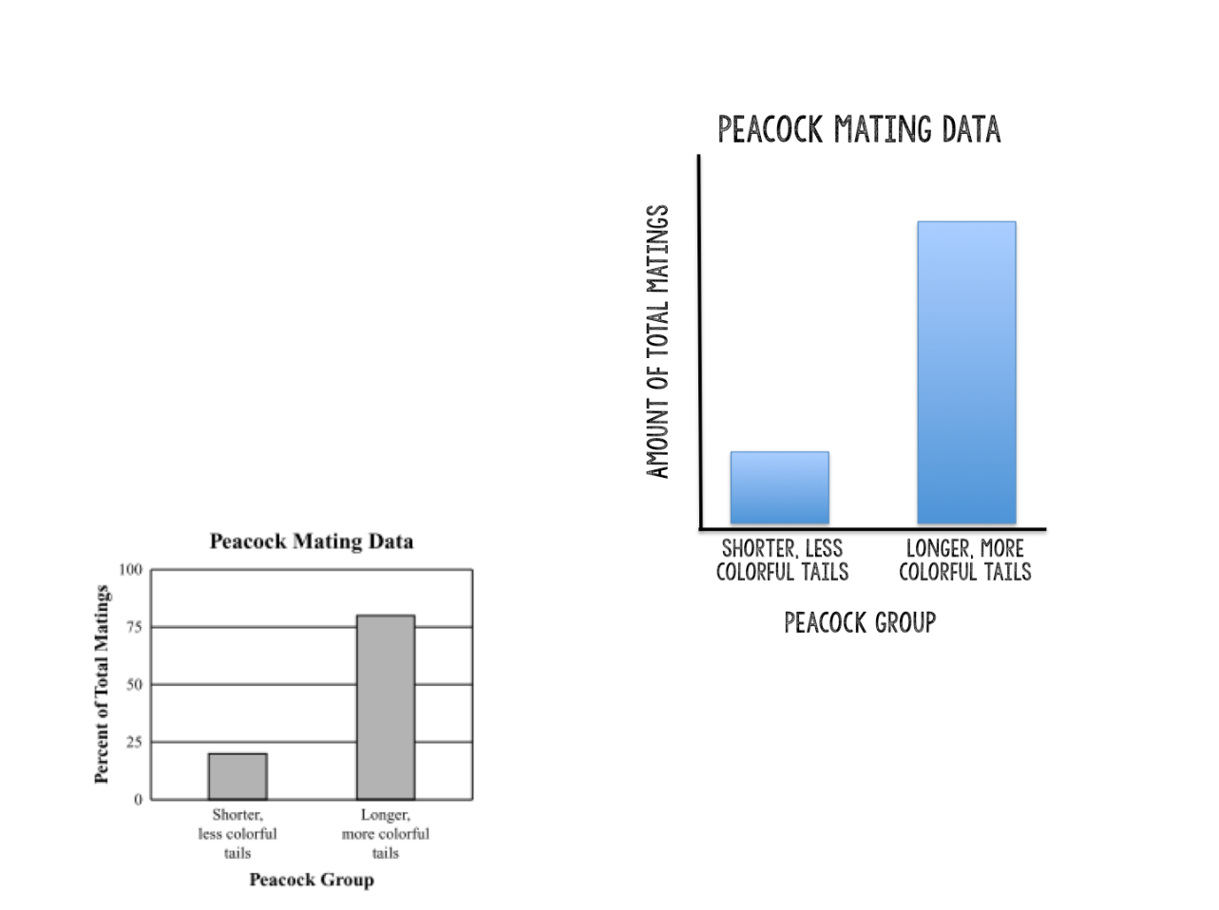

* 1. **Explain** what the graph shows about the advantage of longer, more colourful tails for peacocks. (1 mark)

______________________________________________________________________________

* 1. Identify **one** disadvantage that longer, more colourful tails may have for peacock.

(1 mark)

______________________________________________________________________________

**Part C: Extended answer** **(9 marks)**

1. **Identify** three forms of evidence for evolution and describe how they support the theory that all organisms share a common ancestor. Ensure that you include an **example** for each source of evidence.

______________________________________________________________________________  
  
______________________________________________________________________________  
  
______________________________________________________________________________  
  
______________________________________________________________________________  
  
______________________________________________________________________________

______________________________________________________________________________  
  
______________________________________________________________________________  
  
______________________________________________________________________________  
  
______________________________________________________________________________  
  
______________________________________________________________________________

______________________________________________________________________________  
  
______________________________________________________________________________  
  
______________________________________________________________________________  
  
______________________________________________________________________________  
  
______________________________________________________________________________

______________________________________________________________________________  
  
______________________________________________________________________________  
  
______________________________________________________________________________  
  
______________________________________________________________________________  
  
______________________________________________________________________________

______________________________________________________________________________